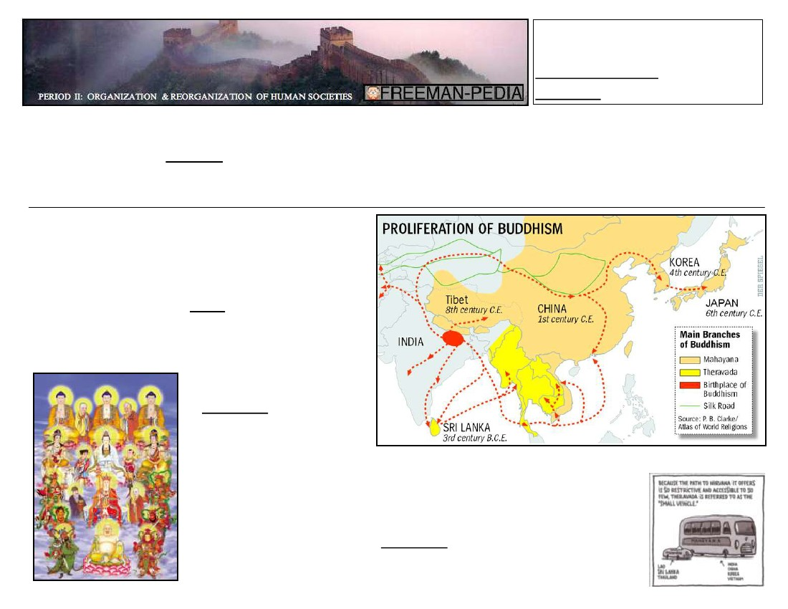
RELIGIOUS AND CULTURAL
TRADITIONS WERE
TRANSFORMED AS THEY
SPREAD.
In the wake of the decline of the Classical Empires, both Buddhism & Christianity expanded rapidly. So, when you think of the end of the Classical era,
match that with the rise of Buddhism & Christianity as major world religions. One reason for their growth was the onset of plague that devastated
Classical populations. Political instability turned people inward in a search for spiritual solace. Hinduism also changed as it spread through the
subcontinent of South Asia. Syncretism (the blending of the old beliefs with the new beliefs) was common as Christianity and Buddhism simply added
local traditions to their dogma. Some common characteristics of Christianity, Buddhism, and Hinduism include:
▪
Emphasis on inner devotion/piety
▪
Stress on Spiritual concerns over Secular
▪
Better life in the Afterlife
▪
Response to political instability/poverty
BUDDHISM
BODHISATTVAS
Although it was founded in India (see the map→), Buddhism remained
but a small minority in its homeland. The main way that Buddhism
spread was through the work of Monks (known as Bhikku, literally
“beggar”; a person devoted to living a simple life and attaining
Nirvana). Buddhism was divided among a small number of devoted
monks and a large number of those who continued about their daily
lives while trying to meet their spiritual obligations.
A new idea that arose within
Buddhism in this era was the doctrine
of Bodhisattvas. These are people
who reached nirvana but chose to stay
in this world as a kind of Saint.
These Bodhisattvas would then serve The East Asian form of Buddhism that emerged was Mahayana Buddhism. Known as the
as an example to others and aid them “Greater Vehicle” because more people could reach salvation, Mahayana Buddhism
would often see the Buddha as divine. This runs contrary to earlyin prayers.
Buddhism changed from its focus on
ethics to a devotional, emotional cult
stressing popular salvation.
Bodhisattvas were crucial in guiding
people towards this salvation.
Buddhist teachings. Theravada Buddhism required the follower
to devote their life to Buddhist teachings (something fewer people
were able/willing to do). Buddhism never dominated a society;
rather, it co-existed alongside other dominant religions leaving its
largest impact in Korea, Vietnam, and Japan.
SYNCRETISM: Buddhism should have changed Chinese
Patriarchy (Buddhism teaches that women have souls!) They
changed Buddhist phrases from “Husband supports wife” to
“Husband controls wife”.

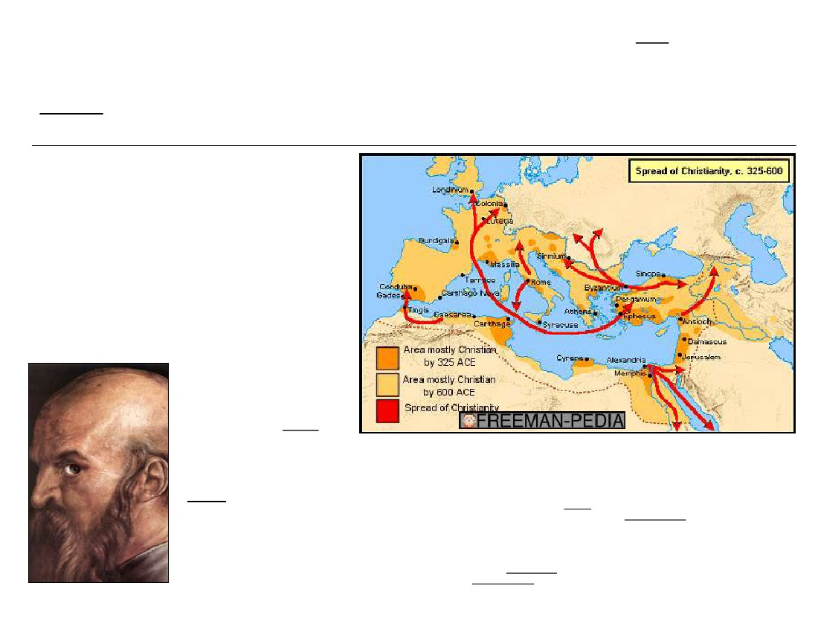
HINDUISM
Christianity
While Buddhism spread east from its birthplace, Christianity spread west.
Christianity (although much slower to spread/convert) would end up having
the largest impact of any of the Classical religions. Christianity was the
driving force in the development of both Post-classical Eastern Europe and
Western Europe. Christianity and Buddhism did share some similarities
(emphasis on Salvation and spiritual guidance of the Saints). However,
there are far more differences.
Christianity put more of a focus on the hierarchy and organization
of the church itself (basing this on the Roman Empire’s structure…
Pope=Emperor, etc.) Missionary work played an even larger role in
Christianity than it did in Buddhism. One key feature of Christianity, more
than any other religion, was the exclusive nature of its beliefs and the
intolerance of others beliefs (initially the
PAUL of TARSUS
Romans, later the Jews).
200 years before Jesus, several
reactionary groups to the rigidities of
Jewish priesthood arose. Many of these
taught of the coming of a Messiah (Savior)
who would bring about the Final
Judgment. This movement culminated in
Jesus of Nazareth.
Jesus taught around Israel and
gathered a small, loyal group of followers
or Disciples. Once Jesus crucified, his
followers expected his return, and with his
return, the End of the World. When this
did not happen, the disciples spread out
across the Roman Empire.
Greek/Roman religion had grown
stale, especially to the poor. Christianity’s
emphasis a simple life and the spiritual
The Classical/Post-Classical era saw changes
come to the ancient religion of Hinduism.
The new devotional focus was led by
Hymnodists. The Hymnodists composed
music and taught in the local vernacular (the
language spoken by the people).
Another change to Hinduism was the addition of personal, devotional gods or Bhakti. These had existed since
the Upanishads (commentaries on the Vedas), but now took on a larger role. They were now highly charged
with emotion with special focus on the relationship between the worshipper and the divinity.
The new Tamil “Saints” stressed this intense love for the Bhakti in poetry or hymns. These poems were often
accompanied with song and dance. They often encouraged the virtues of love, humility, and brotherhood. This
new intense focus on spiritualism further weakened Buddhism, already in decline in India. Occasionally,
resulting in aggressive persecution of the Buddhist Minority
equality of everyone (not to mention the rituals the early Christians developed, Communion, etc.) gained it
attention all over the Empire. The Roman Empire’s reach allowed for easy travel across its great size for the
missionaries. They even went beyond to Axum, Persia, and Ethiopia. As the Empire fell, people turned to this new
religion for comfort/spiritual solace.
Paul of Tarsus (an early convert, but not an original Disciple), led this effort to spread the teachings of
Jesus and helped solidify it into a true religion (rather than a Jewish reform movement). This included the
establishment of a formal church organization, with a Bishop appointed for each region. The writings of early
converts and other stories were collected into what would become the New Testament (in the early 4th century).
Early on, the Christians had to compete with other “Mystery religions”. After years of persecution (from
a normally tolerant Imperial government), the Roman Emperor Constantine converted. This was the first huge
convert (later followed by Clovis (France), Vladimir (Russia)).
Early Christian ideas to develop include the Trinity (God, Jesus, Holy Spirit), and the tying of Classical
philosophy to Christian beliefs. Also, Monasticism developed under Benedict in Italy with peasants he converted
from the worship of Apollo. SYNCRETISM: Christmas=Roman Winter Solstice Holiday. Churches built using
Roman architectural styles.

