Mrs. Rudd’s Guide to Better Notes – WHAP 2016-17
The Notebook Rubric below is how your notes will be graded. Please note the emphasized suggestions below in order to:
- Make your notes easier to study/review (after all, isn’t this why we are note taking in the first place?)
- Make your notes concise and easier to remember
- Get as much effectiveness from your notes while saving as much time as possible.
Notebook Evaluation Sheet
VISUAL APPEARANCE / ORGANIZATION (20)
- Work is Neat and Organized
- *Headings on all Pages
- *Proper and Effective Use of Color
- Key terms and Key concepts are included and stand out
QUALITY AND COMPLETENESS (60)
- Notes and right-side work is complete and of high quality
- Left-side work is complete and shows processing of the work done on the right side.
- Evidence of following instructions.
- *Includes graphic representations of thought
- No missing work (even if absent).
EDUCATION (20)
- Obvious evidence of time invested
- Obvious evidence of learning.
- Effort and quality of work are exceptional.
TOTAL ______/(100)
HEADINGS for all titles, subtitles, and new sections are important for organization
Key terms and key concepts are emphasized in order to be easy to locate and study.
Use COLOR to emphasize important concepts. Try color-coding your highlighting according to S.P.I.C.E. themes.

Represent your notes by using mapping arrows to demonstrate progression or chronology ⇒ ⇒ ⇒
Use Graphic Representations/concept webs/pictures to help you remember important material AND cut down on time writing

WRITING NOTES IN FULL SENTENCES IS SILLY! Sentences are not conducive for studying or locating information quickly.
- NOTE-TAKING = ABBREVIATIONS, ARROWS, BULLET POINTS, CONCEPT WEBS, GRAPHIC REPESENTATIONS
- ESSAYS = FULL SENTENCES, IN PARAGRAPH FORM. No exceptions in WHAP.
Example --
Long Version: The Franklin Expedition was a British attempt to find a Northwest Passage through the Arctic Ocean to the Pacific. Three ships carrying 128 men left in 1845 under the command of a naval officer, Sir John Franklin. The crew was not well equipped for Arctic survival. The expedition was lost with no survivors.
Shorter Version: Franklin Exped. (1845):
- Br. attempt to find NW Passage⇒Pacif. via Arctic O.
- 3 ships, 128 men— comm. by nav. off. Sir J. Franklin
- poorly equipped for Arct. =all died.
FOCUS ON MAIN IDEAS AND IMPORTANT CONNECTIONS. NEVER USE FULL SENTENCES ON PERSONAL NOTES INTENDED FOR STUDY. Always abbreviate long words and terms that are used repeatedly in the lecture. If your teacher is lecturing about the Pleistocene Era, for example, you could write Pl. Era. If the lecture is about Sir John A. Macdonald, use his full name in your heading; then refer to him as Mac or simply as M. ⇒
Here are some commonly used abbreviations and symbols. You should make up your own code of note-taking symbols to suit each subject matter and your personal style.
SYMBOL |  | ABBREVIATION
+ and |  | imp. important
= equals, is, was |  | def. definition
↑ up, increased |  | ex. example
→ became, led to |  | p. page
↓ down, decreased |  | ch. chapter
~ about, approximately |  | bkgd. background
w with |  | re. regarding
w/o without |  | diff. different
N.B. very important |  | b. born (followed by date or place)
e.g. for example |  | d. died (followed by date or place)
i.e. that is (in other words…) |  | govt. government
# number; therefore |  | amt. amount
@ at |  | contd. continued
¶ paragraph |  | pos. positive
vs. against |  | neg. negative
c. around (used before dates) |  | WW2 World War II
$ money, dollars |  | psych. psychology
♀ female |  | Ind. Rev. the Industrial Revolution
≈ approximately, about |  | Ren. the Renaissance

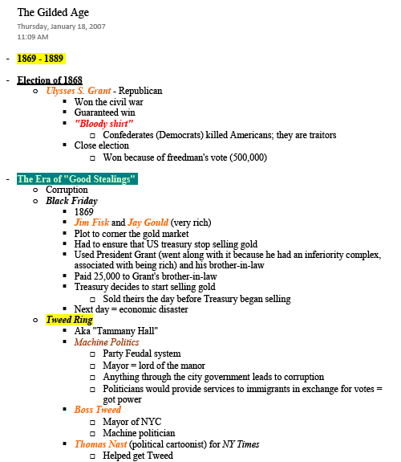
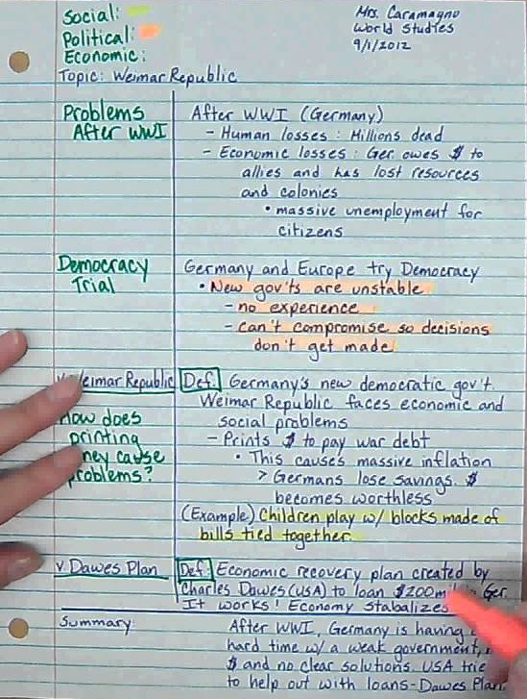
Outline Notes Example: Cornell Notes Example:

