Name: __________ANSWER KEY_______________________________ Date: __________________ Period: _________
EUROPE MAP TEST STUDY GUIDE
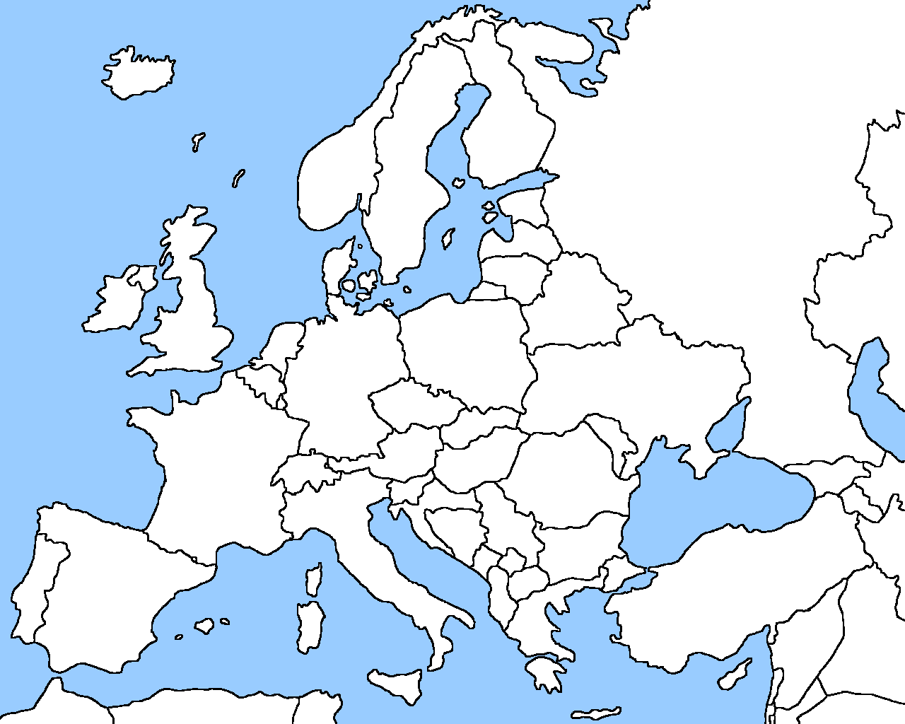
34
40
6
39
20
37
38
36
35
33
32
31
30
29
28
27
26
25
24
22
23
21
19
18
17
16
15
14
13
12
11
10
9
8
7
5
4
1
3
2

# | Country | Capital | # | Country | Capital
1 | Portugal | Lisbon | 21 | Macedonia | Skopje
2 | Spain | Madrid | 22 | Montenegro | Podgorica
3 | France | Paris | 23 | Albania | Tirana
4 | Ireland | Dublin | 24 | Bosnia and Herzegovina | Sarajevo
5 | United Kingdom | London | 25 | Serbia | Belgrade
6 | Belgium | Brussels | 26 | Greece | Athens
7 | Netherlands | Amsterdam | 27 | Bulgaria | Sofia
8 | Denmark | Copenhagen | 28 | Romania | Bucharest
9 | Germany | Berlin | 29 | Kosovo | Pristina
10 | Poland | Warsaw | 30 | Iceland | Reykjavik
11 | Czech Republic | Prague | 31 | Norway | Oslo
12 | Slovakia | Bratislava | 32 | Sweden | Stockholm
13 | Hungary | Budapest | 33 | Finland | Helsinki
14 | Austria | Vienna | 34 | Vatican City | n/a
15 | Italy | Rome | 35 | **(Africa)
16 | Switzerland | Bern | 36 | Russia | Moscow
17 | Corsica | Ajaccio | 37 | Atlantic Ocean
18 | Sardinia | Cagliari | 38 | Balearic Islands | Palma
19 | Slovenia | Ljubljana | 39 | Malta | Valletta
20 | Sicily | Palermo | 40 | Luxembourg | Luxembourg City

