Indian Classical Religions
Hinduism
Background
Started in the wake of the Indo-European Aryan invaders. The cities of Harrapa and Mohenjo-Daro dissolved and pasted into the historical record. The light skinned Aryans implemented a system that favored their position in the new emerging caste system, which is the corner stone of the Hindu religion.

Crash course world history you-tube video of the beginning of India’s Hindu history

http://www.youtube.com/watch?v=n7ndRwqJYDM

Founder – biography
Hinduism has no single founder or central holy person

Sacred Texts
- Vedas
- Rig-Vedas
- Bhagavad Gita
- Upanishads – writings which formed the basic religious construct of Hinduism
- Rayamana
Core beliefs/basic doctrines
- Believe in a divine force (aka universal soul, divine essence) informing the universe and every creatures soul is thought to be a part of the divine life force
- Polytheistic with multiple manifestations of the One divine essence
  - Lord Brahma – The Creator
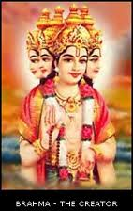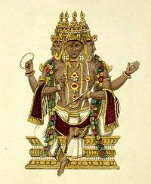
  - Shiva the destroyer
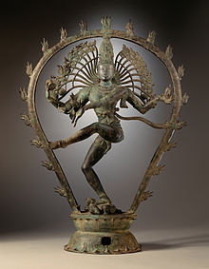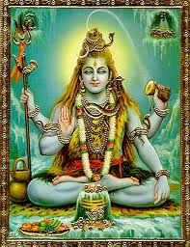

  - Vishnu the preserver
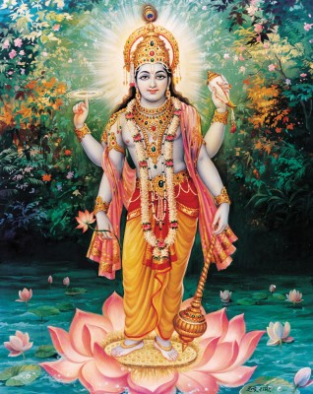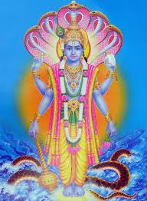

  - Ganesh
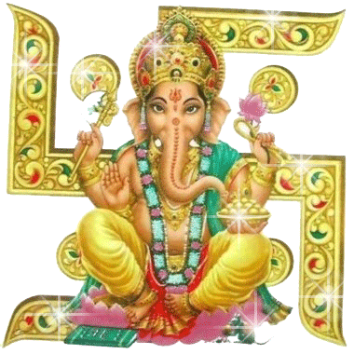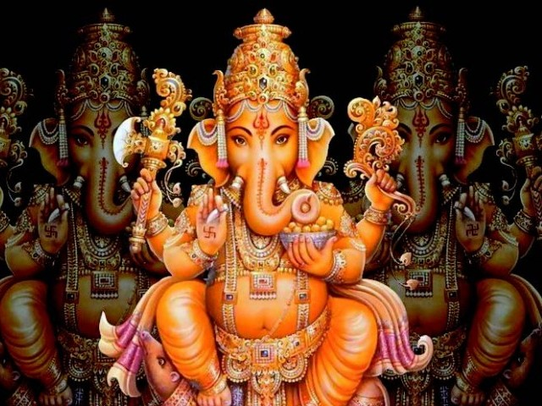

- Gods and Goddesses regulated natural forces and possessed human qualities
- Goal is to achieve nirvana or oneness with the universal soul
- People achieve nirvana through reincarnation through multiple life cycles
- Karma is the moral force of a humans actions that determine if they enter a higher or lower caste in the next life
- Four principle aims of human life:
- Dharma: obedience to religious and moral law
- Artha: pursuit of economic well-being and honest prosperity
- Kama: enjoyment of social, physical, and sexual pleasure
- Moksha: salvation of soul

Crash course world history you-Tube video about Ashoka and Buddhism:
http://www.youtube.com/watch?v=8Nn5uqE3C9w&feature=relmfu

Impact on society
Hinduism and the Caste system form the social construct of India and provide the moral basis and ethical standard for behavior in India. It is the dominant characteristic of India’s history

Spread/growth
Hinduism has never spread beyond the region of India. It did spread within the region of India as it was propagated by early Brahmin leaders and gurus taught the concepts of the divine essence and reincarnation.

Buddhism
Background
It emerged in the predominantly Hindu backdrop of India.

Founder – biography
- Siddartha Gautama – rich prince groomed to become a governor who when he observed the suffering of the lower castes decided to abandon his families wealth and live a life of meditation and personal discipline. He left his wife, family, and the comforts of wealth to become a holy man.
- During his wandering Siddartha spent 49 days sitting under a bodhi tree meditating and trying to understand suffering. He endured temptations from demons but eventually achieved “enlightenment” and earned the title “Buddha”
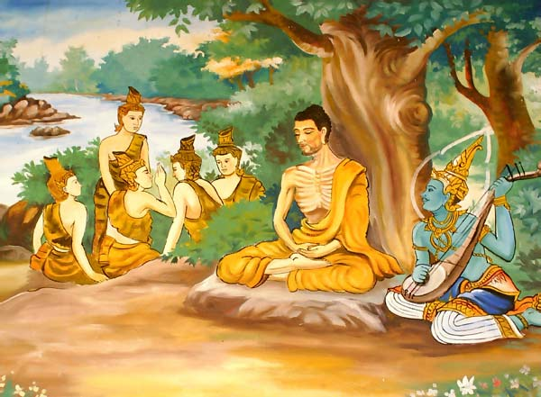
Sacred Texts
- Tripitaka
- Mahayana Sutras
- Tibetan Book of the Dead
- To read more: http://www.religionfacts.com/buddhism/texts.htm
Core beliefs/basic doctrines
- Main teachings: Four Noble Truths
First: life is full of suffering
Second: suffering is caused by desire
Third: The way to end suffering is to end desire
Fourth: The way to end desire is to follow the eight-fold path
Eight-fold path: right belief, right resolve, right speech, right behavior, right occupation, right effort, right contemplation, and right meditation
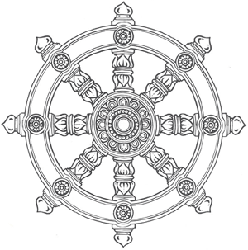
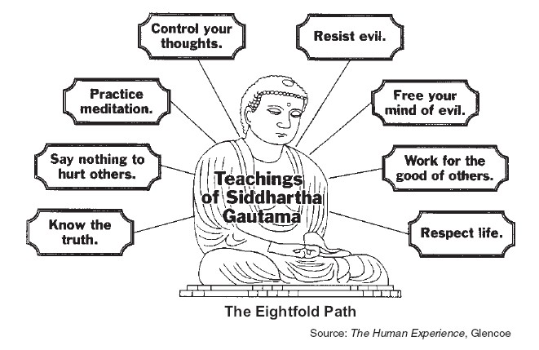
- The goal is the achievement of nirvana, oneness with the universal soul
- Buddhist reject the caste system
- Buddhist believe you can achievement enlightenment breaking the cycle of reincarnation to arrive at nirvana in a single life cycle
- Egalitarian nature of Buddhism along with the preaching of Buddhist monks and the zealous building of monasteries after the conversion of Ashoka led to significant growth of the religion
- Over time Buddhism divided into several lines of thinking
1. Therevada Buddhism was closely connected to the original example set by Siddartha and was an extreme ascetic approach of self-denial and self-sacrifice
2. Others began to view Buddha as a divine being who is to be the object of worship and devotion
3. Boddhisatva – meaning “enlightened being” people who had reached enlightenment of the perfected state and who earned the reward of nirvana but intentionally delayed their entry to nirvana so that they could help others achieve enlightenment
4. Mahayana Buddhism – version of Buddhism with simpler requirements based on acts of generosity and compassion
Impact on society
At first Buddhism because of its rejection of the caste, was persecuted by the Hindu religious leaders. Buddhism gained a big boost when the Mauryan Emperor Ashoka converted to Buddhism and made Buddhism legal within India.

Spread/growth
Buddhism took root and grew when it was made legal by Ashoka. Buddhism developed a system of monasteries for monks to go and meditate and seek enlightenment. Buddhism spread as monks following established trade routes began to seek out new places to establish monasteries. Buddhism spread throughout SE Asia and across the silk roads all the way to China, Korea and Japan.



China
Philosophy/Religion:

Crash Course History you-tube video on history of China

http://www.youtube.com/watch?v=ylWORyToTo4&feature=related

Legalism
Background
Emperor Qin Shi Huangdi was the most ardent proponent of this theory. Emperor Qin’s reign was in fact short because of his desire for punishment and blood. He took legalism to an extreme.

Founder – biography
- Shang yang was founder
Sacred Texts
- Works known as “The Book of Lord Shang”
Core beliefs/basic doctrines
- Argued that the strength of the state is found in its agriculture and armed forces and that as many individuals as possible should farm or be in the military, which discouraged most other careers
- Starts with a basic belief that human nature is “Evil” and that people can only be controlled by harsh enforcement of strict laws and that the state was the mechanism of enforcement
Impact on society
After Qin dynasty only a small remnant of true legalists remained with only minimal influence

Spread/growth
Beyond China, legalism is often associated with religious interpretation in which a person beliefs in strict adherence to the principles of their belief

Confucianism
Background
Born in the turmoil of the Era of Warring States, Chinese thinkers began to look for ways to explain the violence and to maintain order even in the midst of troubling times

Founder – biography
Kung Fuzi (Confucius)
Mencius - – a disciple of Confucius – was a major contributor to the advancement of Confucian ideals during the Han dynasty

Sacred Texts
- Confucius writing’s are found in a work known as the “Analects”

Core beliefs/basic doctrines
- Confucius did not address religious or spiritual questions
- Confucius never discussed the concept of the right kind of government (as Plato did in Greece)
- According to Confucius political and social harmony came from the proper ordering of human relationships rather than the establishment of a specific form of government
- Moral integrity and a capacity to make wise and fair judgments are the trademark of a Confucian trained scholar
  - Ren – kindness, benevolence, sense of humanity (heart)
  - Li – custom of respect and courtesy among people
  - Xiao – filial piety or proper order of the relationship within the family
  - 5 basic relationships
- Ruler to ruled
- Husband to wife
- Father to eldest son
- Eldest Son to younger son
- Neighbor to neighbor
Confucianism’s overarching goal is to maintain an orderly society

Impact on society
After the Han Dynasty, Confucianism becomes the primary guiding principle of the Chinese Empire until the end of the dynastic tradition in 1912.
The bureaucracy will be continually filled with scholar-gentry that only earns their positions because of their mastery of Confucian teaching and principles.
Confucianism also impacts Chinese society by providing the core ethical system that guides all personal interactions. It focuses on proper manners and the appropriate interactions of people in the 5 basic relationships.
Confucianism also promotes political awareness

Spread/growth
Confucianism was adopted by Korea, Japan, Vietnam as the primary political system for their leaders as tribute empires to China. The experiment with Confucianism in Japan was short lived and not very successful
Outside of East Asia, Confucianism has had little impact.

Daoism/Taoism
Background
Daoism emerges at the same time as Confucianism. It is the spiritual counterpart to the philosophical dimension of Confucianism. Many consider Daoism and Confucianism to be the spiritual yin and yang of China. Daoism focuses on the spiritual real while Confucianism focuses on the ethical realm.

Founder – biography
- Founded by Laozi
Sacred Texts
- Teaching contained in Daodejing (Classic of the Way and of Virtue)
Core beliefs/basic doctrines
- Unlike Confucianism, Daoism is the effort to understand the character of the universe
- Dao means “The Way of nature” or “the way of the cosmos”
  - Dao is like water which is soft and yielding yet is also so powerful that it erodes even the hardest rock
  - Emphasis is on balance and harmony with nature
  - Yin- Yang strong and opposing forces resisting against each other until balance is achieved
  - Daoist devoted energies to reflection and introspection


Impact on society
While Daoist believed that Confucianism was a striving after things that couldn’t be understood it was in reality a nice blending of spiritual essence with moral code of Confucianism

Spread/growth
Daoism is not found outside of China
Greek Religion/Philosophy
Polytheism
Background
Emerging out of Greece’s archaic period the Gods were formed out of Chaos and took on specific duties to help order the universe.

Founder – biography
Similar to Hinduism there is no single founder of Greek polytheism. Much of Greek mythology is based in the archaic period of the Minoans and Mycenaean’s. Greek mythology starts with the creation of the earth and its elements out of Chaos and the creation of an entire pantheon of god’s.

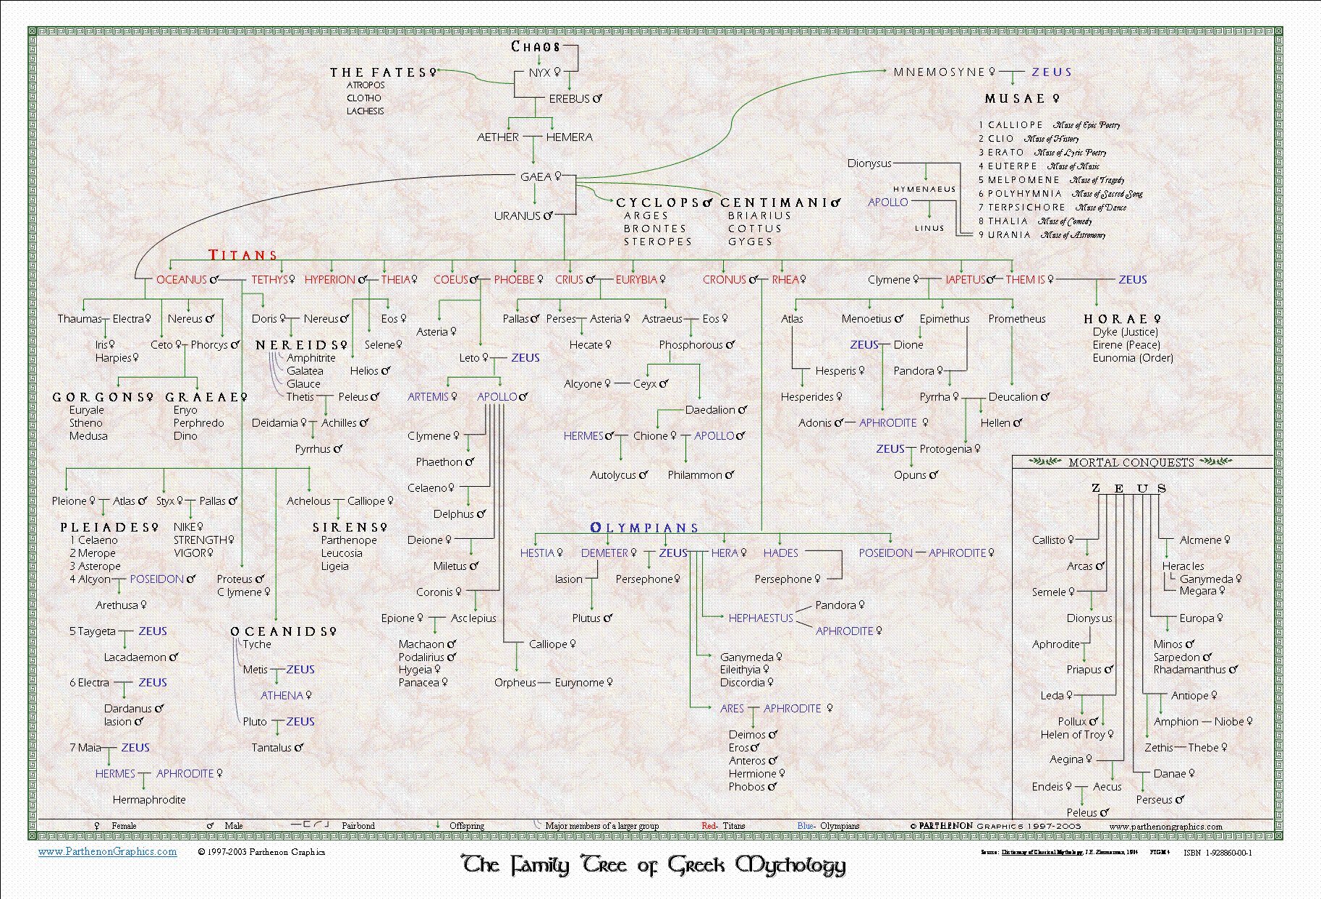

Sacred Texts
There are no known specific texts that chronicle the gods and there interactions with man although Homer’s Iliad and Odyssey were considered authentic accounts of the struggle between men and the gods.

Core beliefs/basic doctrines
- Though the Greek city-states were fiercely independent entities they shared common cultural connections and religious ideals.
- The Greeks were Polytheistic with a vast array of gods
- Greek gods were anthropomorphic meaning that they had human characteristics. They were human looking in form, they were jealous, angry, fell in love, and had very human emotions. The Greek gods often interfered in the affairs of humans and on occasion those interactions were personal and sexual with the offspring having both human and supernatural characteristics
- The gods lived on Mt. Olympus and there were 12 major deities who determined the fate and fortunes of human beings.
- Zeus was the supreme god who was associated with the heavens, lightening, and kingship.
- Poseidon was the god of the sea
- Hades was Lord of the underworld
- Hera (Zeus’s sister) was god of marriage
- Apollo was the god of the sky, truth, and healing
- Aphrodite was the goddess of love and beauty
- Athena goddess of wisdom and war
- Artemis god of the moon and the hunt
- Hestia was the god of hearth and home
- Hephaestus god of fire and forge
- Ares god of war
- Hermes – messenger and divine herald

Creation stories explaining how the gods emerged out of Chaos
Many cults devoted to specific gods provided avenues of worship of varying forms some of which were devoted only to women such as the worship of the goddess Demeter and the most famous was the cult of Dionysus where the women danced, sang, got drunk and ripped open a sacrificial animal

Impact on society
While typical Greek citizens paid homage to the Gods, Greek polytheism was not very satisfying to the average citizen. The gods were unpredictable and there was no specific set of standards or ethics that were associated with the worship of the gods.

Spread/growth
Greek polytheism was completely adopted by the Roman Empire who simply renamed the Greek gods with Latin names. After the fall of the Roman Empire, however, the concept of the Greco-Roman pantheon died out in practice and in theory.
Unlike the other great classical civilizations Greco-Roman polytheism had no lasting effect.

The Philosophers
The philosophical developments of the Greeks became the foundation of thinking in the western world. Reaching all the way to the founding of the United States the Greek philosophical foundation of observation, rational inquiry, and questioning form the basis of developments in the western world.

Socrates  - Socrates is worried about the present life and how to live it best  - “The unexamined life is not worth living”  - Search for truth and the meaning of truth  - Question everything | 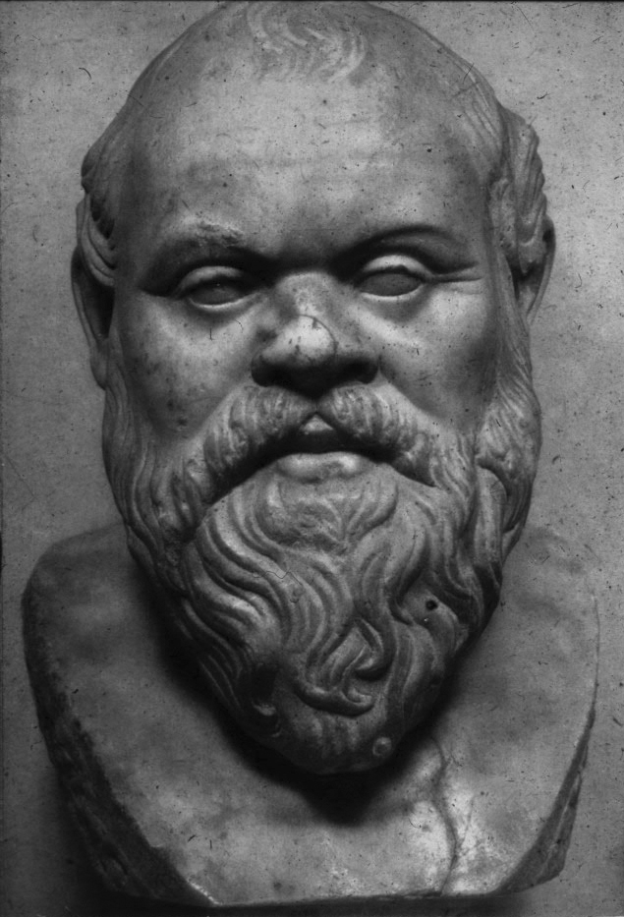
Plato  - Perfect form  - Allegory of the Cave  - Most famous work – The Republic – discussed the perfect form of government | 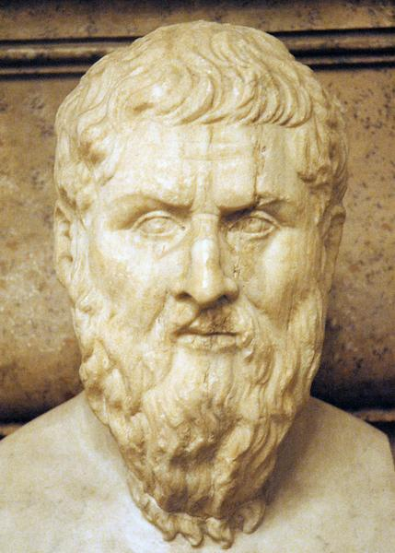
Aristotle –  - Tutored Alexander The Great  - The first to distinguish between subject matters and invented the concept of “disciplines” to be studied.  - Formalized the rules of logic  - Developed the idea of deductive reasoning  - Provable conclusions  Can’t know an item until we know what it was designed to achieve | 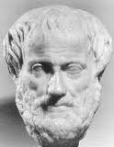

Roman Religion
Greek Gods – redefined
- Roman polytheism was a copy of all things Greek with most of the deities simply being renamed.
- Again like the Greeks, Roman deities were anthropomorphic gods possessing human characteristics and who got involved in the affairs of humans as a way to test the character and courage of those humans.

Like the Greeks 12 main Gods ruled from Mt. Olympus

Greek God | Roman Name | God of
Zeus | Jupiter: | King of the Gods
Hera | Juno | Queen of the Gods
Poseidon | Neptune | The Sea
Hades | Pluto | The Underworld
Hestia | Vesta | Hearth and home
Athena | Minerva | Wisdom and War
Artemis | Diana | Moon and hunt
Apollo | Apollo | Light, music, and prophecy
Aphrodite | Venus | Love and beauty
Hephaestus | Vulcan | Fire and forage
Ares | Mars | War
Hermes | Mercury | Messenger and Divine Herald

Temples dedicated to the gods were built throughout the Roman Empire for worship, rituals, ceremony, and sacrifice

Christianity
Background
During the reign of Augustus in a remote province of Judea on about the 3BCE another of the world’s great classical religions came into being when an itinerant preacher was born to a common Jewish carpenter – Jesus of Nazareth.
Jesus grew up in Judea and around the age of 30 he went into the wilderness to fast and pray. During the fasting in the desert he overcame being tempted by the devil. He emerged from the wilderness and began to preach a message about the kingdom of god calling people to repentance and salvation based on a message of love. According to the gospel accounts Jesus ministry was filled with miraculous occurrences, compassion for the outcasts, and strong condemnation for the established religious organization.
His preaching angered the established Jewish religious leaders and Roman officials thought that his action and claims were seditious. In about 30 CE he was trialed by a Roman court and sentenced to death by crucifixion.

Crash course world history you-tube video on the development of Christianity

http://www.youtube.com/watch?v=TG55ErfdaeY

Founder-biography
Jesus of Nazareth called the Christ (Christ means “anointed one”)
Other notable personalities: the twelve disciples, the Apostle Paul

Sacred Texts
Bible
- Consists of two parts.
- First is the Old Testament, which chronicles the history of the ancient Jews and their covenant with a single God.
- Second is the New testament, which contains the four gospels detailing the life and ministry of Jesus as well as a multitude of letters written by Paul and other disciples to the churches in Asia Minor
Core beliefs/basic doctrines
- Jesus as the Son of God entered the human experience through the immaculate conception and the virgin birth
- Trinity: God the Father, Jesus the Son, the Holy Spirit each composing a unique part of the God head with Jesus being the human incarnation of the one true God.
- Jesus message was of love and forgiveness with a focus on everlasting life for those who believe.
- Jesus as the Son of God was crucified to pay the penalty for the sin of humankind
- Jesus is believed to have been resurrected from the dead giving him supremacy over life and death
- Salvation for the believer is gained through faith in Christ’s death and resurrection
Impact on Society
- His disciples and followers believed that Jesus had resurrected from the dead and they continued to proclaim the message that Christ had preached – they became known as Christians
- Initially the religion was persecuted and many attempts were made by Roman leaders to crush the followers and stamp out its influence but early church leaders such as the apostle Paul continued to go from city to city telling people about Christ and the religion continued to grow
- Eventually Christianity would be embraced by the Emperor Constantine and be made the official religion of Rome
- Christianity is commonly accepted as one of the causes of the fall of the Roman Empire. The message of love and forgiveness, the call for equality among all people was a shift from the highly militaristic and self-indulgent final centuries of the Empire. The message of Christ provided spiritual comfort and hope for people at just the time when the established polytheistic religion had widely been discounted.
Spread/growth
Like Buddhism, Christianity was spread readily along the established trade routes of the Roman Empire. The Roman road system made travel from location to location very easy. Preachers such as Paul and the twelve disciples went from city to city and met in local Jewish synagogues and city centers preaching about Jesus and gaining a following.
Christianity would eventually rise to be the cornerstone religion of Western Civilization and spread through most of the known world.
Three main branches:
- Roman Catholicism
- Eastern (Greek) Orthodox
- Protestants
- Lutherans, Calvinists, Anglicans, Baptists, Methodists, Pentcostals

Persia

Crash Course History you-tube video on the Persians and the Greeks
http://www.youtube.com/watch?v=Q-mkVSasZIM&feature=relmfu

Zoroastrianism

Background
This monotheistic religion was a product of ancient Persian civilization. Many scholars think it possible that the early Hebrews got their ideas of monotheism from Zoroastrianism, though no direct link has been established. Followers were called Parsis which meant “Persian.” Many were forced from Persian with the arrival of the Muslims in the 7th and 8th centuries and traveled to the Bombay area of India where a small community of Parsis still live.

Founder
Zarathustra is believed to have lived around 600 BCE though many think he may have lived as early as 1500BCE.

Core Beliefs
- The world was originally perfect but became a cosmic battleground between the forces of good and evil. People have to choose to live a good or evil life. Those who choose good, simple lives will go to heaven and be united with God, but those who choose evil will go to hell.
- Zoroaster predicted that one day the earth would be restored to perfection again.
- Purity is of great importance and any form of decay should be avoided.
- Death with its bodily decay is seen as the temporary victory of evil.
- Death rituals include “towers of silence” where the dead are placed on towers so that the flesh can be consumed by birds, because the earth should not be contaminated with decaying flesh and cremation is not possible since first is sacred.
(Note: information on Zoroastrianism was taken exclusively from The Usborne Book of Word Religions)

