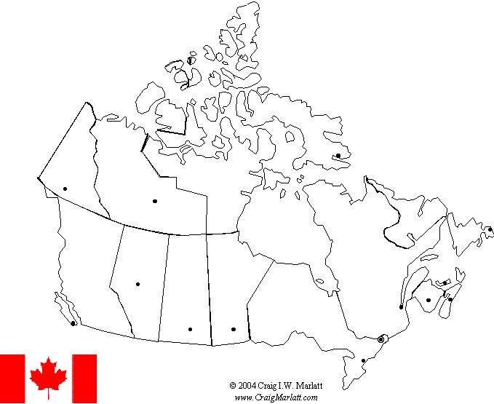
Name: _________________________________
CANADA MAP TEST STUDY GUIDE
15
DIRECTIONS: Label AND color the map of Canada. Each PROVINCE should be a different color.

TEST DATE: ____________________
THERE WILL BE NO WORD BOX ON THE TEST!
20
13
14
9
19
18
17
7
12
11
10
8
6
5
4
3
2
1
# | Province | Capital | # | Province | Capital
1 |  |  | 11
2 |  |  | 12
3 |  |  | 13
4 |  |  | 14
5 |  |  | 15 | What country?
6 |  |  | 16 | What body of water?
7 |  |  | 17
8 |  |  | 18
9 |  |  | 19
10 | (Canada’s National Capital) |  | 20 | What US State?
16

