Crash Course World History #8
Alexander the Great and the situation…the Great ?

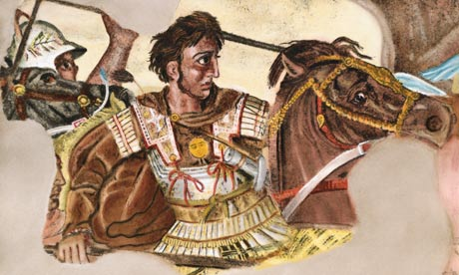

Key Concepts
Key Concept 2.2: The Development of States and Empires
As the early states and empires grew in number, size and population, they frequently competed for resources and came into conflict with one another. In quest of land, wealth, and security, some empires expanded dramatically. In doing so, they built powerful military machines and administrative institutions that were capable of organizing human activities over long distances, and they created new groups of military and political elites to manage their affairs. As these empires expanded their boundaries, they also faced the need to develop policies and procedures to govern their relations with ethnically and culturally diverse populations: sometimes to integrate them within an imperial society and sometimes to exclude them. In some cases, these empires became victims of their own successes. By expanding boundaries too far, they created political, cultural and administrative difficulties that they could not manage. They also experienced environmental, social and economic problems when they over-exploited their lands and subjects and permitted excessive wealth to concentrate in the hands of privileged classes.

- The number and size of imperial societies grew dramatically by imposing political unity on areas where there had previously been competing states.
- Empires and states developed new techniques of imperial administration based, in part, on the success of earlier political forms.

Key Concept 2.3: Emergence of Trans-regional Networks of Communication and Exchange
With the organization of large-scale empires, the volume of long-distance trade increased dramatically. Much of this trade resulted from the demand for raw materials and luxury goods. Land and water routes linked many regions of the Eastern Hemisphere, while somewhat later separate networks connected the peoples and societies of the Americas. Exchanges of people, technology, religious and cultural beliefs, food crops, domesticated animals and disease pathogens developed alongside the trade in goods across far flung networks of communication and exchange.

- Land and water routes became the basis for trans-regional trade, communication and exchange networks in the Eastern Hemisphere, while somewhat later separate networks connected the peoples and societies of the Americas.
- New technologies facilitated long-distance communication and exchange.
- Alongside the trade in goods, exchanges of people, technology, religious and cultural beliefs, food crops, domesticated animals and disease pathogens developed across far-flung networks of communication and exchange.

Directions:
1. Read the Key Concepts. In
2. Preview the video viewing questions.
3. Watch Crash Course #8 Alexander the Great and the Situation… the Great? (http://www.youtube.com/watch?v=0LsrkWDCvxg&feature=share&list=PLBDA2E52FB1EF80C9) once without taking notes.
4. Watch the video again and answer the video viewing questions.

Video Viewing Questions

- In your own opinion, what makes someone deserving of the title, “the Great”?

- What is problematic with viewing history as simply “the study of great men?”

- Complete the chart using information from this video and your textbook. Consider what Alexander of Macedon actually did (accomplished), what occurred as a result of his accomplishment (the by-product), and what legacy is left (and often attributed to Alexander the Great) as a result.

Actual Accomplishment | By-Product | Legacy

- What is the difference between conquest and empire building? Which is a greater accomplishment in your opinion? Be sure to justify your answer with specific examples!

- What became of Alexander’s empire after his death?

- Define Hellenistic.

- How do you want to be remembered?

*If using this video as part of class (not just independent review), have students begin class by writing an argument (thesis and three points outlined) for or against (they chose) the greatness of Alexander of Macedon.

